Apology

Framework

At Life Without Barriers, it is important to say sorry.
Life Without Barriers is sometimes called LWB.
Staff at LWB will sometimes need to say sorry when things go wrong.

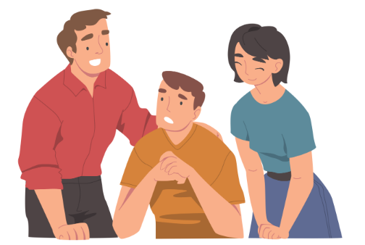

What is in this document?
- This document is called an Apology Framework.
- Framework means rules.
- This document talks about why people and organisations say sorry.

What rules do we follow about saying sorry?

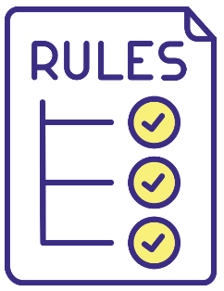
- Staff at LWB follow rules called a National Safeguarding Framework.
- Safeguarding means keeping people safe and well.
- National means LWB staff work all around Australia.

When will LWB say sorry?
- LWB will say sorry if they make a mistake and someone was hurt.
- LWB will say sorry when something bad happens to somebody they care for.
- LWB will say sorry if there is a complaint.
- LWB do not hide mistakes.

Can you give an example of when LWB need to say sorry?
LWB will say sorry if staff:
- Did not come to an appointment and someone was hurt.
- Did not use a person’s money in the right way.

- Took too long to call an ambulance or doctor and the person got more sick or hurt.
- Did not give medicine in the right way and the person got more sick.
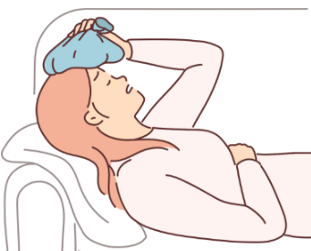
- Did not protect a person from family or house mates who hurt them.
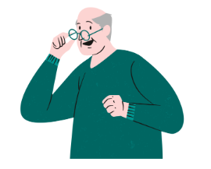
- Did not give a person the care they needed and they were hurt.
- Did not respect a person they care for and hurt their feelings.
- Did not let the person they care for make decisions about their care.

Can saying sorry help?

Saying sorry can be difficult but it is important.

If we talk about what happened, LWB can learn from mistakes.

Saying sorry can help:

- People move on.
- People trust LWB again.
- LWB make sure a person is not hurt again.

How will LWB say sorry?
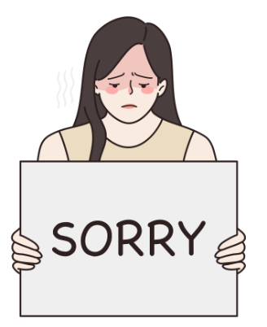
- Staff will say there was a mistake.
- Staff will talk to the person they care for.
- Staff can also talk to family or other people if the person wants them to.
- Staff will say ‘I am sorry’ or ‘We are sorry’.
- Staff will tell the person what will happen next.
- LWB will learn from the mistake.

What is important to LWB?
LWB believe that:
- Relationships are important.
- They must treat everybody with respect and tell the truth.
- Everyone is different. LWB knows they will have to say sorry to different people in different ways.
- They must try hard to understand people and their family.

Do LWB the mistakes?
- Yes, LWB keep notes.
- LWB use i-Sight to make notes about mistakes they make.
- i-Sight is a computer program.
- It helps us stop mistakes from happening.

Where do I find out more information?
You can find more information by clicking the link below:
www.lwb.org.au

