CONTENTS
CONTENTS 1
PURPOSE 2
DEFINITION OF SUPERVISION 2
FORMAT OF SUPERVISION 3
EXPECTED SUPERVISION OUTCOMES 7
MINIMUM STANDARDS OF SUPERVISION 7
SUPERVISION ROLES AND RESPONSIBILITIES 9
SUPERVISION MODES 11
SUPERVISION MANAGEMENT SYSTEMS 12
SUPERVISION AGREEMENT 12
SUPERVISION EVALUATION 13
RELATED DOCUMENTS 13
REFERENCES 13
APPENDIX ONE: Example Line Management and Practice Supervision Responsibilities 15
APPENDIX TWO: Example Practice Supervision Log 16
APPENDIX THREE: Example Line Management Log 19
APPENDIX FOUR: Example Practitioner / Clinical Supervision Agreement 20
APPENDIX FIVE: Example Reflective Practice Template 23
APPENDIX SIX: Continuing Professional Development Template / Learning Goals Achievement Record 24
APPENDIX SEVEN: Example Supervision Evaluation Template 27
APPENDIX EIGHT: Example Case Review Template 30

PURPOSE
The purpose of this Framework is to outline the LWB approach to supporting the members of the Behaviour Intervention Support (BIS) team to access consistent, appropriate, and effective supervision and support.
This Framework is designed to reflect LWB’s values, priorities and safeguarding obligations, and align with requirements stipulated by the NDIS and relevant professional bodies, ensuring staff have the necessary supervision and support to ensure continuous improvement and quality practice.
This Framework is designed to be viewed alongside the following LWB documents:
- National Supervision Policy Guideline and Supervision Frequency Matrix
- General Supervision Resources

DEFINITION OF SUPERVISION
As outlined in the ‘National Supervision Policy Guideline’, supervision in LWB is a multi-functional, relationship-based process. It is comprised of four functions (i) management and accountability (ii) development and educative (iii) supportive and (iv) mediative (National Supervision Policy Guideline, March 2020).
- Management and accountability functions – this is concerned with the support of competent and accountable practice. It includes the efficient and effective use of organisational resources including workload management.
- Developmental and educative functions – this is concerned with the development of staff skill and knowledge.
- Supportive functions – this is concerned with the social support and emotional needs of staff in their roles. This includes considering the emotional impact of the role and ensuring a link is made to support as required. This may also include discussion of personal matters where this is impacting on the work role of the person.
- Mediative functions – this is concerned with the role of the worker in the team and in the broader organisation. It will include negotiation and clarifying roles and responsibilities and interpreting organisational or policy requirements into practice.
The LWB supervision process aligns with models used to inform clinical supervision for allied health professionals (e.g., Kadushin, 1976; Proctor 1987) which generally comprise of three functions:
- Educational/Formative: This domain focuses on educational development, such as the development of skills, reflective practice and the ability to embed evidence-based practice.
- Supportive/Restorative: This domain focuses on the preservation of professional and supportive working relationships to support wellbeing, build resilience and sustain morale.
- Administrative/Normative: This domain focuses on adherence to good standards of work, including following relevant policies and procedures and engaging in ethical and effective practice.

FORMAT OF SUPERVISION
Supervision can be delivered in three relevant formats: informal supervision, formal individual supervision, and formal group/team supervision.
Within the Behaviour Intervention Support (BIS) team supervision is provided across the following domains as appropriate for an individual in the context of their role: clinical supervision; practice supervision; line management and; peer supervision.
Supervision will be provided in a safe and trusted environment, separate to that in which performance management or review may occur. The clinical or practice supervision described in this framework is structured to meet the quality indicators/competency framework and requirements under NDISC.

Clinical Supervision
Clinical supervision is driven by the needs and specific registration of the practitioner in question and is individualised to support best practice within their area of expertise or registration. Supervision of this nature is designed to align with existing applicable professional requirements and meet requirements stipulated by relevant professional bodies (e.g., AHPRA).

Practice Supervision
Practice supervision is driven by the needs of the behaviour support practitioner and is individualised to support best practice, promote reflective practice and allow for the discussion of ethical issues. Practice supervision aims to optimise client outcomes; support staff wellbeing and enable continuous practice improvement.
Practice supervision is provided internally within the National BIS Team (where capacity allows).
The supervision of behaviour support practitioners is a key element of the Positive Behaviour Support (PBS) Capability Framework and has been recognised by the NDIS Commission as “a fundamental mechanism for strengthening practice and building capability of the behaviour support workforce”. It is an expectation under the PBS Capability Framework that all behaviour support practitioners receive supervision.
Supervision of this kind refers to direct professional practitioner supervision by a Behaviour Support Practitioner with a higher or commensurate level of skill and knowledge. Specifically:
- A core level behaviour support practitioner should engage in direct professional supervision from a supervisor who is proficient or above. Independently recommending restrictive practices is outside of the scope of a core practitioner.
- A proficient behaviour support practitioner is expected to participate in supervision, from an advanced or specialist practitioner. In line with the PBS Capability Framework, a proficient practitioner is also expected to (a) provide and participate in peer supervision with another proficient practitioner (if relevant to their supervision schedule) and (b) Supervise a core practitioner (if the proficient practitioner has the skills and knowledge base to do so).
- An advanced behaviour support practitioner is expected to access and participate in supervision as the supervisee, including peer supervision with another advanced practitioner. In line with the PBS Capability Framework, an advanced practitioner is also expected to supervise other practitioners at all other levels.
- In relation to their area of specialisation, a specialist behaviour support practitioner is expected to access and participate in supervision as the supervisee, including peer supervision with another specialist practitioner.
Example practice supervision responsibilities are outlined in Appendix One. An example Practice Supervision Record/Log is included as Appendix Two.
In addition to having a ‘practice’ supervisor registered at a level that aligns with NDIS Quality and Safeguards Commission requirements, the National BIS Team will – wherever practicable – attempt to leverage off the strengths and advantage in its multi-jurisdictional structure by partnering supervisors with supervisees in different jurisdictions. This aim being accelerated growth and development of practitioners through the sharing of best-practice and supporting team-wide growth in the knowledge of differing jurisdiction-based legislation and policy positions.
Practice supervision relationships within the National BIS Team will be reviewed on an annual basis, with a view to rotate supervisors / supervisees to ensure learning and development opportunities can be maximised.

Line Management
Operational line management is focused on service delivery and is typically driven by human resource (HR) and operational management items. Line management refers to direct supervision by a manager who monitors work practice. Example line management responsibilities are outlined in Appendix One. An example Line Management Record/Log is included as Appendix Three.
Within the National BIS Team the functions of Line Management and Practice Supervision will be provided by two different individuals, except in rare circumstances where this is unavoidable. In instances where this is unavoidable, all reasonable steps will be taken to address this duality as soon as practicable. In these instances clear differentiation, both in relation to the initial supervision agreement and during supervision sessions, must be maintained to ensure adequate and individual attention is given to both functions.

Peer Supervision
Peer supervision refers to the support provided between practitioners of the same, or similar, level of expertise which is focused on reflective practice. This is an important element of practice for all practitioners, including core practitioners working towards proficient registration against the PBS Capability Framework. Engagement in peer supervision contributes to the development of skills that will assist core practitioners in providing practice supervision once they self-assess at the proficient level.
As outlined in the PBS Capability Framework, proficient practitioners are expected to provide and participate in peer supervision with other proficient practitioners (if relevant to their supervision schedule). This peer supervision can occur in several forums, including structured professional development settings (e.g., Power Hour) or ad-hoc as appropriate.
Peer supervision is an additional method of reflective practice ONLY. It does not replace the other forms of supervision detailed above.

EXPECTED SUPERVISION OUTCOMES
The Supervision Framework within the Behaviour Intervention Support (BIS) team is designed to deliver the following outcomes:
- Ensure the delivery of quality customer outcomes and maximised client safety.
- Ensure staff feel adequately supported and enable individual practitioner development.
- Enable the development of positive, trusting relationships.
- Ensure appropriate risk management.
- Ensure the effective support of client services teams implementing behaviour support.
- Support the development and advancement of skilled practitioners which will in turn support sector expansion.
- Support and reinforce evidence-based best practice at LWB and compliance against state and federal legislation and policy.
- Complement existing professional requirements for supervision, as stipulated by relevant professional bodies (e.g., AHPRA).

MINIMUM STANDARDS OF SUPERVISION
The minimum standards of supervision apply to members of the Behaviour Intervention Support team:
- Every practitioner will have:
  - A Practice Supervision Record/Log documenting supervision activities (Appendix Two)
  - A Supervision Agreement (Appendix Four)
  - A Reflective Practice Journal (Appendix Five)
  - An Individual Development / Continuing Professional Development Plan (Appendix Six)
  - A Learning Goals Achievement Record (Appendix Six)
- Every BSP / SBSP will have a nominated ‘practice’ supervisor, registered at a level that aligns with NDIS Quality and Safeguards Commission requirements (as outlined above).
- Practice supervisors will have no more than 5 supervisees. In line with the LWB ‘National Supervision Policy Guideline’ all staff in supervisory roles will have completed adequate training to support them in their role.
- Supervision will be of sufficient frequency and duration. The amount of time required for practice supervision will vary depending on the individual’s level of competence, experience, learning style and other factors. The minimum frequency for supervision is outlined in the LWB ‘Supervision Frequency Matrix’. The table below provides a further guide
As a general guide, all members of the National BIS Team will receive one hour of line management per fortnight. All experienced core practitioners and above will also receive one hour of practice supervision.
Line Management | Frequency | Duration |  | Comments
National BIS Team | Fortnightly | 1 hr |  | Applies to entire National BIS Team
Practice Supervision
Practitioner Level | Time in Role |  | Frequency | Duration | Comments
Core | < 6 months |  | Weekly | 1 -2 hrs (reducing over time) | Previous relevant experience should also be considered  Hours may be increased as needed (e.g., times of new skill acquisition)
Core | 6 – 18 months |  | Weekly (or fortnightly as determined in discussion with their supervisor). | 1 hr
Core/Proficient | 18 – 24 months |  | Fortnightly | 1 hr
Advanced/Specialist | NA |  | Fortnightly | 1 hr
* This table provides a guide to Practice Supervision requirements ONLY; supervisors and supervisees should discuss frequency and duration as it applies to an individual practitioner when completing the supervision agreement. This should be reviewed on a regular basis. Frequency and duration may also vary based on client complexity and other forms of supervision a practitioner is receiving.
* In relation to clinical supervision, different minimum standards exist within specific professions which must be adhered to. This is determined by national accrediting bodies and associations. Where relevant, it is the responsibility of the supervisor and supervisee to ensure that the methods, frequency, and duration of supervision meet these standards.
* The above guidelines relate to 1:1 supervision ONLY. Group supervision/peer supervision may occur in addition to this time.
- For practitioners assessed at the level of proficient and above, a minimum of three plans that they have authored will be reviewed by their practice supervisor, or an appropriate peer (i.e., assessed as proficient or above) annually.
- Supervision Evaluations (Appendix Seven) will occur at least bi-annually; this will include a review of the supervision agreement to ensure currency.
- In addition to inclusion in the supervision agreement, confidentiality within supervision will be regularly discussed including limits to confidentially and negotiable/non-negotiable matters. The agreement will also outline how risks raised in supervision will be addressed. This will include an outline of pathways for supervisees to discuss concerns regarding their supervisor with an alternative member of the management team if needed.
- To further support the development of practitioners against the NDIS PBS Capability Framework, all core practitioners will be supported to engage in peer-on-peer supervision. This can occur in several forums, including structured professional development settings (e.g., Power Hour) or ad-hoc as appropriate.
- LWB provides supervisors and staff with procedures, templates, and resources to support the effective implementation of supervision. Some are prescribed and other are offered as a guide to be adapted as needed.

SUPERVISION ROLES AND RESPONSIBILITIES
The goal of supervision should be to develop a practitioner’s knowledge, skills, confidence, competence and professionalism. The following table outlines and responsibilities of the supervisor, supervisee and others in this process.
Supervisor | Supervisee | LWB / National BIS Team
Actively participate in developing a supervision plan. | Actively participate in developing a supervision plan. | Ensure all staff have access to adequate supervision.
Plan and adhere to a schedule for supervision (e.g., recurring appointment in outlook) | Plan and adhere to a schedule for supervision (e.g., recurring appointment in outlook) | Provide support and resources to ensure effective supervision can be implemented.
Engage in ongoing supervision, supporting the supervisee to explore and improve upon their practice and maximising supervision outcomes. | Engage in ongoing supervision and take responsibility for exploring their own practice and maximising learning. | Ensure appropriate performance management processes are followed when needed.
Maintain accurate supervision documentation. Managers are responsible for recording and securely storing evidence of supervision (NB: The occurrence of both Line Management and Practice Supervision should be recorded in MyHR; supervision documentation/logs as they relate to Practice Supervision must be maintained on supervisor/ supervisee drives). | Maintain accurate supervision documentation (NB: The occurrence of both Line Management and Practice Supervision should be recorded in MyHR; supervision documentation/logs as they relate to Practice Supervision must be maintained on supervisor/ supervisee drives). | Adhere to LWB Supervision Guidelines and Procedures, including supporting all members of the BIS team to adhere as appropriate.
Commit to, and follow through on, actions agreed. | Commit to, and follow through on, actions agreed. | Respond to concerns raised by supervisors/supervisees in a supportive, open manner.
Adhere to LWB Supervision Guidelines and Procedures,. | Adhere to LWB Supervision Guidelines and Procedures. | Be open to receiving honest and constructive feedback, and to providing feedback in the same manner when appropriate.
Provide open and constructive feedback when needed and be open to receiving feedback in the same manner. | Be open to receiving honest and constructive feedback, and to providing feedback in the same manner when appropriate. | Maintain confidential records (as appropriate and within practice limitations).
Report upon performance management concerns, including any breach of legislation and/or code of conduct, in a prompt and timely manner when needed. | Report upon concerns, including any breach of legislation and/or code of conduct, in a prompt and timely manner when needed. | Report upon concerns, including any breach of legislation and/or code of conduct, in a prompt and timely manner when needed.
Maintain confidential records (as appropriate and within practice limitations). | Maintain confidential records (as appropriate and within practice limitations).

SUPERVISION MODES
Supervisors and supervisees should discuss preferences around mode of supervision. The preferred mode of supervision will depend on the needs of the practitioner, the capacity of the supervisor and factors such as geographical location. Supervision can be provided using a mix of modalities.
- Face to Face: Where possible, supervisors and supervisees should meet in person. This can provide scope to include activities such as direct observations or co-facilitation (e.g., functional assessment interviews or staff training).
- Distance/Electronic: This can occur when the supervisor and supervisee are unable to meet in-person. Telephone, Microsoft teams or other web-based platforms may be used. As this form of supervision can pose a challenge around some activities more easily engaged in during in-person supervision, discussion should be had around how these challenges can be overcome (e.g., practitioners gaining consent to take video footage of facilitating staff training).

SUPERVISION MANAGEMENT SYSTEMS
Life Without Barriers provides supervisors and staff with procedures, templates, and resources to undertake quality supervision together in structured sessions. Some are prescribed and other are offered as a guide to be adapted as needed.
Supervision session occurrence and regularity should be documented on staff files. The occurrence of both Line Management and Practice Supervision should be recorded in MyHR. In addition, supervision documentation/logs as they relate to Practice Supervision must be maintained on supervisor/supervisee drives. For further support and information see the intranet page Supervision in Disability, Aged Care and Mental Health Services (e.g., Quick Reference Guides on Using MyHR to record formal individual supervision).
A number of general supervision resources and practice tools are also available on the Intranet here.

SUPERVISION AGREEMENT
Supervisors and supervisees must collaborate on the completion of a supervision agreement at the commencement of the supervision arrangement, ensuring that supervision is culturally appropriate and respectful and balances the needs of LWB and the individual practitioner. The agreement (Appendix Four) will clearly outline:
- Roles and responsibilities.
- Mode of supervision.
- Frequency and duration.
- Needs of supervisee (e.g., learning styles; accommodations or adaptations needed).
- Frequency and duration of meetings.
- Expectations regarding preparation (e.g., what and how much will be done before sessions).
- Expectations regarding follow-up and agreed actions between sessions.
- Agreement regarding contact/additional support between sessions.
- Confidentiality agreement (e.g., negotiable and non-negotiable matters; limits on confidentiality regarding supervisor’s own supervision; recording of client information).
- Expectations around review and evaluation.
- Clarification regarding actions that taken in response to potential breach of policy/code of conduct.
- A response plan should the issue of ongoing conflict become apparent. This should include how this can be resolved in the initial stages and actions to take should resolution not be possible.

SUPERVISION EVALUATION
Supervision evaluation should occur at least bi-annually with the focus of the evaluation to ensure the supervision is meeting both the supervisees and supervisor’s needs.
The supervision evaluation provides the opportunity for discussion of how the supervision relationship is going and whether there is any need for changes. It also allows for a review of goals and ongoing planning or adaptation to CPD planning as needed.

RELATED DOCUMENTS
- National Supervision Policy Guideline and Supervision Frequency Matrix
- Supervision Procedure – Disability, Aged Care & Mental Health
- Additional Resources to Support Supervision in DACMH Services
- General Supervision Resources
- NDIS Positive Behaviour Support Capability Framework

REFERENCES
- SA Health – Allied Health Clinical Supervision Framework, March 2014
- NDIS Quality and Safeguards Commission (2019). Positive behaviour support capability framework: For NDIS providers and behaviour support practitioners. Penrith, Australia: NDIS Quality and Safeguards Commission.
- Self-assessment Resource Guide for the Positive Behaviour Support Capability Framework
- Smith, M 1996, 2005, The functions of supervision, The encyclopedia of informal education, Last updated September 2009.
- Health Education and Training Institute, 2012. Best Practice Governance Framework for Allied Health Education and Training, NSW accessed 09/08/13. http://www.heti.nsw.gov.au/resources-library/allied-health-best-practice-governance-framework/
- Proctor, B. (1994). Supervision: Competence, confidence, accountability. British Journal of Guidance & Counselling, 22(3), 309–318. https://doi.org/10.1080/03069889400760331
- Victorian Allied Health Clinical Supervision Framework, Dept of Health and Human Services, May 2019
- Proctor, B. 1987, ‘Supervision: A co-operative exercise in accountability’ in Marken, M & Payne, M (eds) Enabling and Ensuring. Supervision in practice, National Youth Bureau, Leicester
- Kadushin, A 1976, Supervision in Social Work, Columbia University Press, New York, (2nd ed., 1985).

APPENDIX ONE: Example Line Management and Practice Supervision Responsibilities
Line Management  Relates to the operational management of an individual employee / team. | Practice Supervision  Driven by the needs of the practitioner, practice supervision is individualised to support best practice, promote reflective practice and allow for the discussion of ethical issues. It relates to the exploration of clinical matters and is part of a practitioner’s professional development.
- General wellbeing discussions;  - Day-to-day people management, including ensuring organisational policies and procedures are followed;  - High-level caseload management support (e.g., snapshot and capacity review, adherence to timeframes; record maintenance; intake and onboarding issues)​;  - General ‘People and Culture’ matters (e.g., leave planning, performance feedback);​  - Supporting performance against KPI’s and discussion of barriers to resolve (Client, People, Service Quality and Commercials);  - Training needs / professional development planning​ (alongside Practice Supervisor);  - Ensuring compliance and best-practice requirements are met (e.g., data accurately entered into record management systems);  - Use of internal systems (e.g., dashboards) to ensure accuracy of client data.  - Address concerns that relate to operational systems and processes and refer for support as appropriate;  - Resource sharing, as relates to line management responsibilities;  - Address other business-related matters and refer on for support as appropriate (e.g., claiming issues, service agreements, NDIA).​ | - Wellbeing discussions and debriefing;  - Discussion of client caseload and practice related concerns;  - Review of Positive Behaviour Support Plans and other support plans;  - Supporting performance against KPI overview (Client, People, Service Quality and Commercials);  - Training needs and professional development planning​ (alongside Line Manager);  - Resource sharing, as relates to practice supervision;  - Supporting engagement in reflective practice;​  - Engaging in in-depth clinical discussions as it relates to the provision of services (e.g., assessment, test selection, formulation, intervention design and strategy selection, implementation and evaluation​);  - Discussion of ethical considerations​;  - Provision of education in clinically related topics and development of practitioner knowledge and skills;  - Supporting the development of practitioner capability in line with IDP and PBSCF;  - Monitoring work and checking quality, in line with PBSCF requirements;  - Provision of technical expertise as needed.

APPENDIX TWO: Example Practice Supervision Log
NB: As per Supervision Procedure: Disability, Aged Care and Mental Health

Employee’s Name: |  | Role (Job Title):
Area: |  | Region/Operational Unit:
Date: |  | Date Next Supervision:
Start Time: |  | End Time:
Supervisor’s Name: |  | Role (Job Title):
Signed: Signed:

Employee Supervisor
Date:
Signed Copy to Employee Signed Copy to Supervisor

REVIEW OF PREVIOUS SUPERVISION SESSION
It is important to ensure continuity of supervision and ensuring follow-up of any outstanding or unresolved issues and identify:
- progress achieved on specific goals or strategies identified in previous supervision,
- the completion or otherwise of specific tasks/actions agreed to in the previous supervision period,
- the current status of identified challenges/issues that the employee had agreed to work on in the intervening period, and
- Impediments to or supports in achieving the planned outcomes from the last supervision session.

agenda for this supervision session
1. | 4. | 7. | 10.
2. | 5. | 8. | 11.
3. | 6. | 9. | 12.

supervision discussions
Item | Discussion | Action / who | DUE Date

APPENDIX THREE: Example Line Management Log
Employee’s Name: |  | Role:
Supervisor’s Name: |  | Role:
Date: |  | Date Next Supervision:

agenda for this Line management meeting
1. General Wellbeing | 4. Supporting Performance against KPIs | 7. Other
2. High Level Caseload Management | 5. Operational Systems and Processes | 8.
3. Dashboard Review / Data Accuracy | 6. Training Needs/PD Opportunities | 9.

Item | Discussion | Action / who | DUE Date

APPENDIX FOUR: Example Practitioner / Clinical Supervision Agreement
Agreement Details
Date of Agreement
Supervisee
Supervisor
Relevant Needs of Supervisee/Supervisor | e.g., learning styles; accommodations or adaptations needed
Supervision Evaluation Date
(at least bi-annually)
Supervision Review Date
(at end of supervision agreement)

Supervision Details
Relevant Professional Bodies (if applicable) | e.g., AHPRA / AASW
Mode of Supervision | e.g., face-to-face / electronic
Frequency of Sessions | e.g., fortnightly / weekly
Length of Sessions (approx.) | e.g.., one hour
Contact/Additional Support Between Sessions
Content of Supervision | i.e., short summary of main areas of focus based on practitioner registration level / specific areas of expertise and areas of interest/development need
** In relation to clinical supervision, different minimum standards exist within specific professions which must be adhered to. This is determined by national accrediting bodies and associations. It is the responsibility of the supervisor and supervisee to ensure that the methods, frequency and duration of supervision meet these standards.

Confidentiality and Supervision Records
It is broadly agreed here that the content of supervision meetings is confidential between the parties, but that where there are issues regarding client, practitioner or others safety, clinical risk and/or performance management, information may need to be shared with other relevant parties.
Should information need to be shared, the supervisor will advise the supervisee in advance of this occurring, including what information will be shared, with whom and for what purpose.
How will sessions be recorded? | The occurrence of Practice Supervision should be recorded in MyHR. Supervision documentation/logs must be maintained on supervisor/supervisee drives
Who will record sessions?
Where will records be stored?
Who will have access to the records?
What will happen to the records if the supervisee/supervisor leaves the position? | Notes will be maintained/archived in line with relevant record management policies
Additional details regarding the threshold for when information discussed in supervision might need to be shared and with whom? | e.g., negotiable and non-negotiable matters; limits on confidentiality regrading supervisor’s own supervision

Roles and Responsibilities (e.g., expectations regarding follow-up and agreed actions between sessions; expectations regarding session preparation)
The supervisor will respond to, and for prepare for, meetings by…
The supervisee will respond to, and for prepare for, meetings by…
Should a meeting need to be rescheduled we agree to…

Positive Behaviour Support Learning Goals (nb: these goals should be reflective of those included in the practitioner’s Individual Development / PD plan)
Learning Goals | Actions | Resources

Proposed Response Plan (i.e., what actions will be taken in a problem arises in the supervision process)
Should the issue of ongoing conflict, or other issues in the supervisor/supervisee relationship become apparent, the following actions will be taken:

Standing Agenda Items (i.e., any additional agenda items which may need to be discussed not already covered)

Agreement
Supervisor name: | Supervisor signature: | Date:
Supervisee name: | Supervisee signature: | Date:

APPENDIX FIVE: Example Reflective Practice Template
Description – What happened (be factual)
Feelings – What were you thinking and feeling at the time?
Evaluation – What was good and bad about what happened?
Analysis - What sense can you make out of what happened?
Conclusion – What else would you have done or perhaps should have done?
Action Plan – If this happens again, what would you do differently; or is there something you need to do now to ensure if does not happen again (or to minimise the risk)?

APPENDIX SIX: Continuing Professional Development Template / Learning Goals Achievement Record
NB: Reflective of the Individual Development Plan as per LWB template
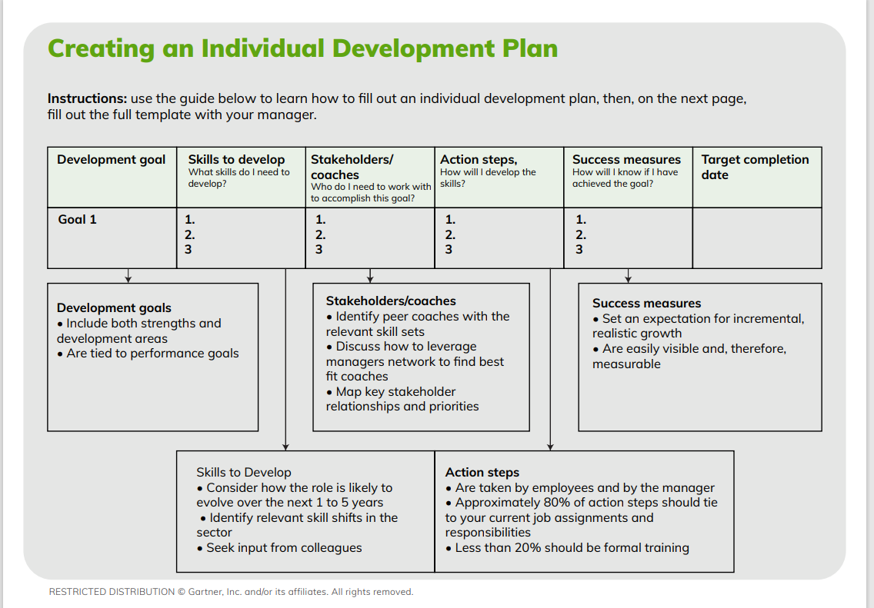
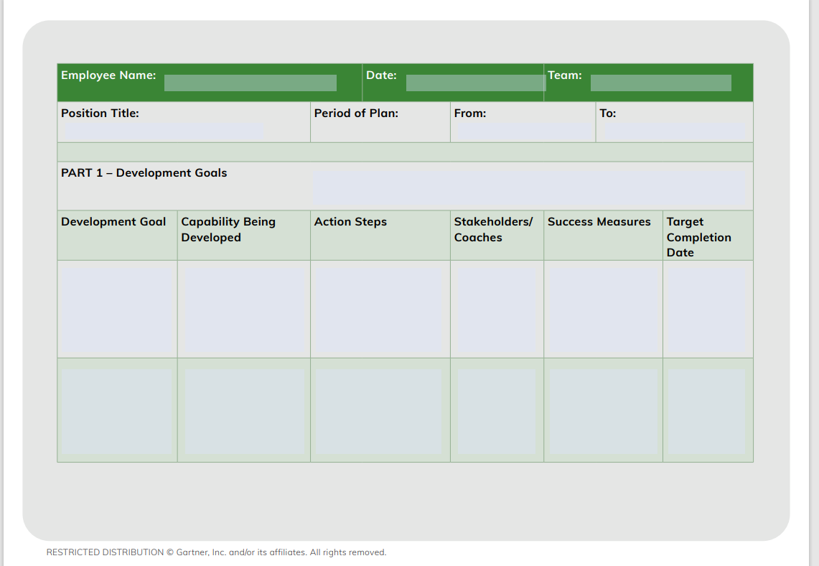
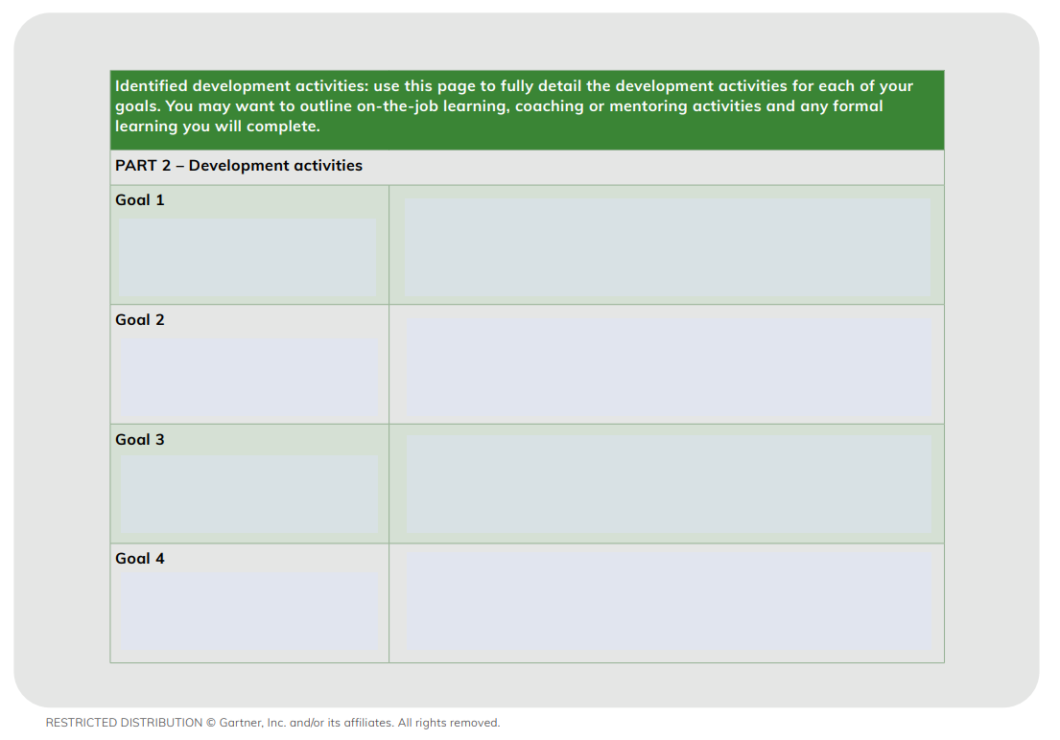
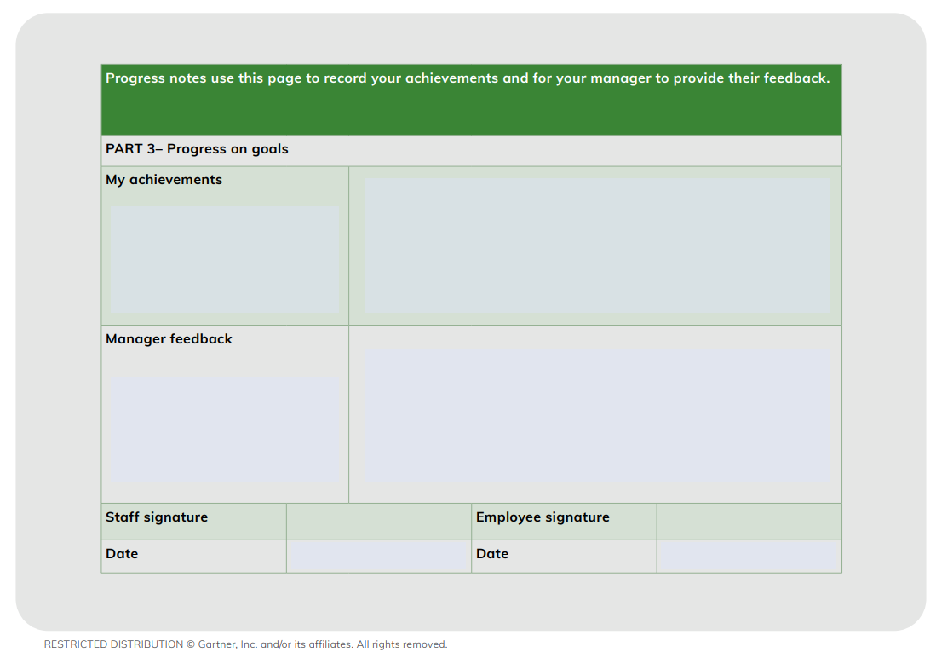

APPENDIX SEVEN: Example Supervision Evaluation Template
Supervisor:
Supervisee: |  |  |  | Signature:
Date:
Supervision Evaluation
- The method of supervision I receive is meeting my needs
Strongly Agree  o |  | Agree  o | Neutral  o |  |  | Disagree  o | Strongly Disagree  o
Comments:

- The frequency and duration of clinical supervision I receive is adequate and meeting my needs
Strongly Agree  o |  | Agree  o | Neutral  o |  |  | Disagree  o | Strongly Disagree  o
Comments:

- I have a good working relationship with my supervisor
Strongly Agree  o |  | Agree  o | Neutral  o |  |  | Disagree  o | Strongly Disagree  o
Comments:

- Supervision encourages me to talk about my practice in ways that are comfortable for me
Strongly Agree  o |  | Agree  o | Neutral  o |  |  | Disagree  o | Strongly Disagree  o
Comments:

- Supervision encourages me find my own solutions to challenges I experience in my work
Strongly Agree  o |  | Agree  o | Neutral  o |  |  | Disagree  o | Strongly Disagree  o
Comments:

- Supervision encourages me to engaged in reflective practice
Strongly Agree  o |  | Agree  o | Neutral  o |  |  | Disagree  o | Strongly Disagree  o
Comments:

- Supervision supports me to develop the knowledge and skills identified in my Professional Development Plan.
Strongly Agree  o |  | Agree  o | Neutral  o |  |  | Disagree  o | Strongly Disagree  o
Comments:

- Supervision supports me to develop the knowledge and skills identified in relation to my Self-Assessment against the PBS Capability Framework.
Strongly Agree  o |  | Agree  o | Neutral  o |  |  | Disagree  o | Strongly Disagree  o
Comments:

- I receive positive reinforcement when I acquire new skills and knowledge
Strongly Agree  o |  | Agree  o | Neutral  o |  |  | Disagree  o | Strongly Disagree  o
Comments:

- My supervisor and I are both meeting the expectations we set out in the supervision agreement
Strongly Agree  o |  | Agree  o | Neutral  o |  |  | Disagree  o | Strongly Disagree  o
Comments:

- Supervision follows a plan and each session results in an action plan
Strongly Agree  o |  | Agree  o | Neutral  o |  |  | Disagree  o | Strongly Disagree  o
Comments:

- Other comments regarding supervision over the past 12 months

APPENDIX EIGHT: Example Case Review Template
CASE REVIEW TEMPLATE
This form is only a guide, and may be altered to meet relevant need
Date of Review:
Brief Background Details (e.g., age; living situation, diagnoses)

Service Goal/Reason for Referral

Approach to Supports to Date

Assessment Outcomes to Date (e.g., formulation/hypotheses/summary statements)

Recommendations to Date

Outcomes of Interventions to Date / Next Steps (e.g., working/not working)

Questions for Discussion

NDIS Quality and Safeguards Commission, 2019. Positive behaviour support capability framework: For NDIS providers and behaviour support practitioners. Penrith, Australia: NDIS Quality and Safeguards Commission
The National BIS Team is committed to ensuring appropriate supervision is provided to all practitioners. The National BIS Team is currently supporting a number of proficient practitioners through to advanced status to ensure all proficient practitioners can access supervision from an advanced/specialist practitioner.

