Please direct all questions to covidresponse@lwb.org.au

The following posters should be displayed at all times within each LWB Residential Property
Document Title | Action | Visual
STOP Health Declaration | - Place at the entrance to the property so staff and visitors see prior to entering. | 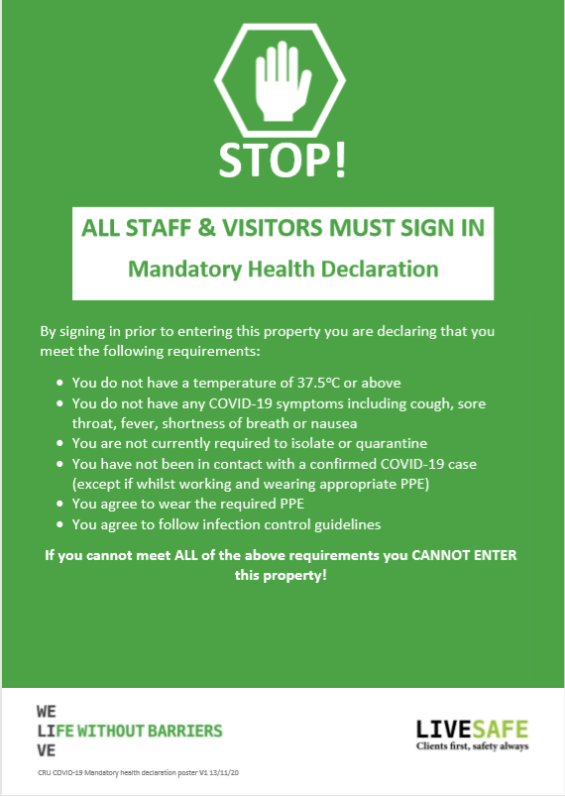
QR Code Sign In | - Place near the entrance to the property so staff and visitors see prior to entering.  - All Staff & Visitors to sign in using the QR code | 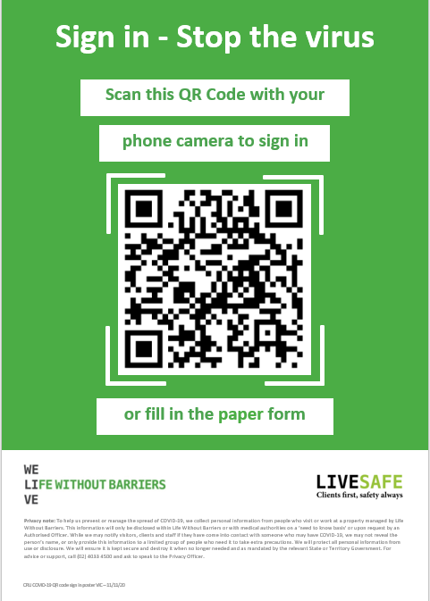
Face mask - donning and doffing | - Place near donning and doffing stations. | 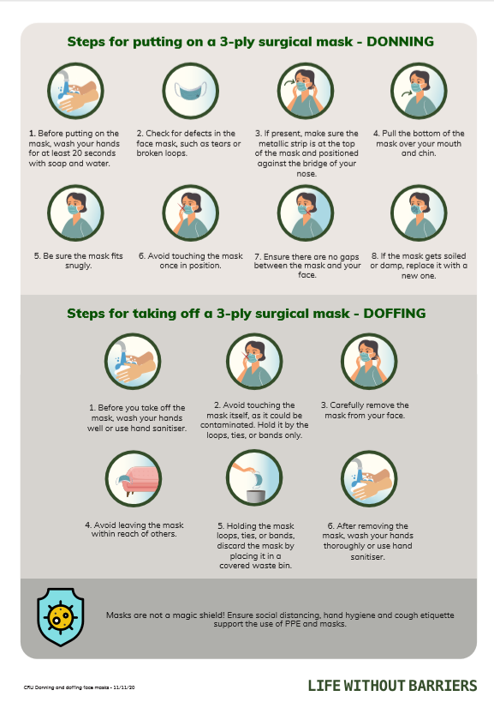
Face shield - donning and doffing | - Place near donning and doffing stations. | 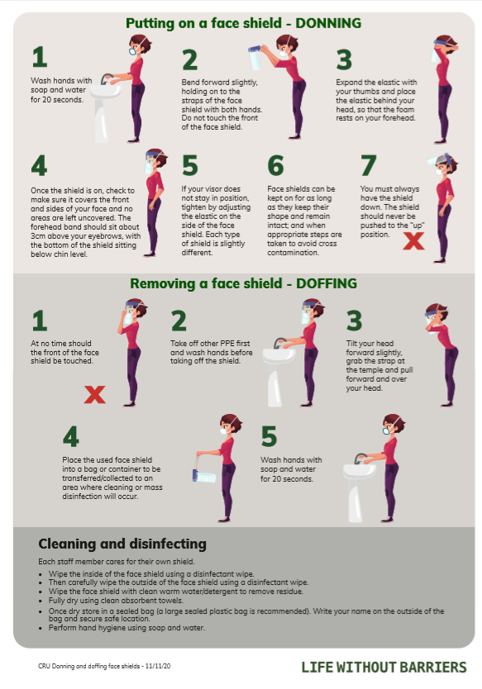
Stop the spread | - Replace existing poster and dispose of old version. | 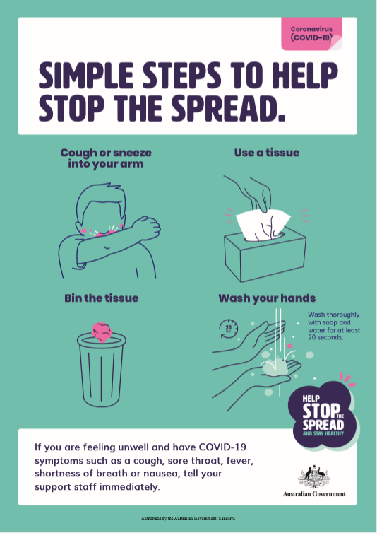

In addition to the above the following posters should be displayed when there is a positive Covid-19 case within an LWB Residential Property.

Document Title | Action | Visual
PPE Positive Case | - Replace existing poster and dispose of old version. | 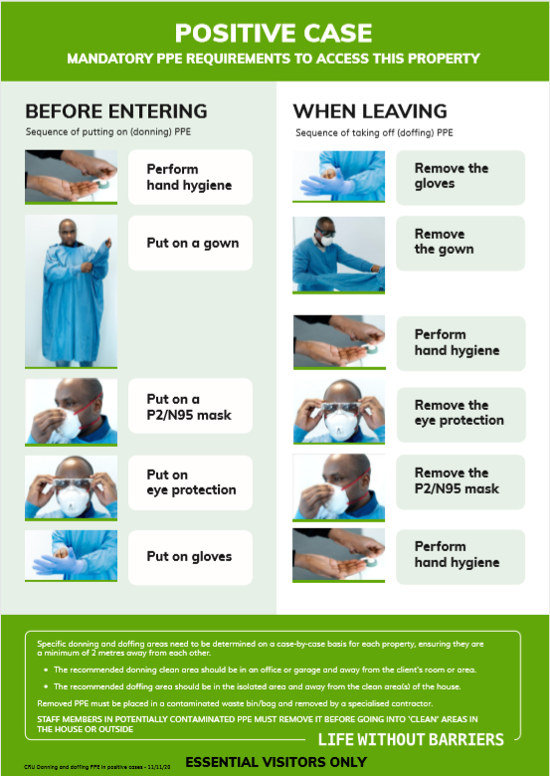
COVID-19 Positive Case – Doffing Sign | - Replace existing poster and dispose of old version. | 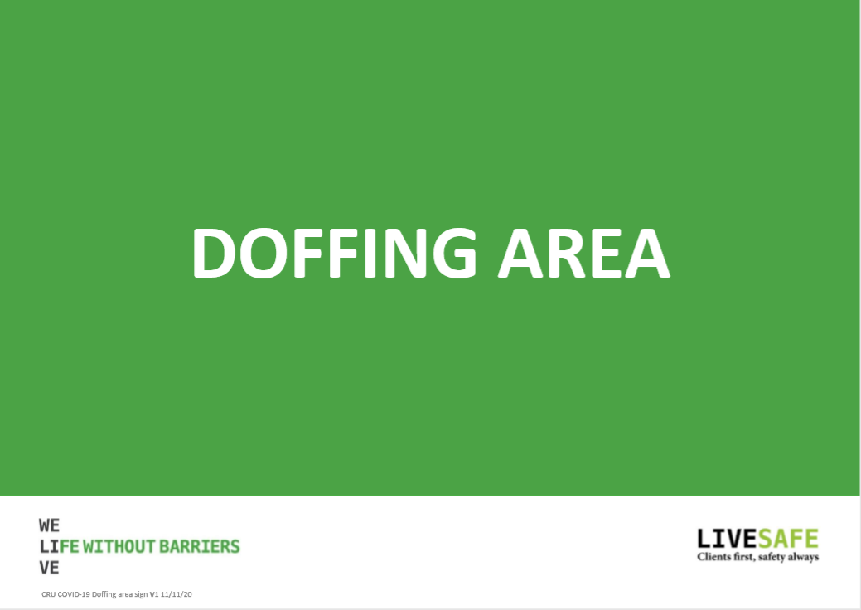
COVID-19 Positive Case – Donning Sign | - Replace existing poster and dispose of old version. | 