USEFUL CONTACTS
Emergency:
- Police, Fire and Ambulance– 000
- DCP After Hours Support Lince – 13 16 11
- CYF National After-Hours Service
- Child Abuse Report Line – 131 478
- Lifeline– Phone 13 11 14 for crisis support when feeling suicidal or if you need to talk to someone immediately.
- Mental Health Assessment and Crisis Intervention Service– Phone 13 14 65
- Health advice by Health direct registered nurse, available 24/7 at 1800 022 222
NAME | ROLE | PHONE NUMBER | EMAIL
 | DCP Worker
 | LWB Child and Family Practitioner

Employee Assistance Program
Our Employee Assistance Program (EAP) supports employees, carers, and their immediate family members in navigating life's many challenges. Call 1300 687 327 (24/7) or book an appointment online (Online Booking (converge-online.com), Organisation Code: LIFEHOAK.

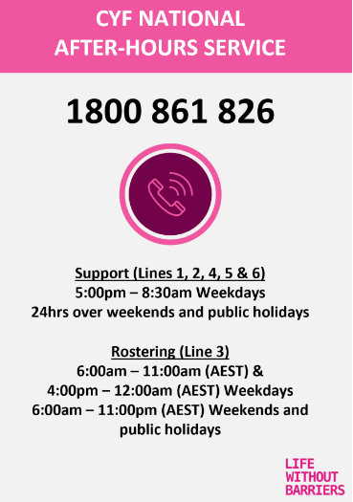
Guardian for Children and Young People - promotes and protects the rights and best interests of children and young people in care.
Phone: 08 8226 8570 Email: gcyp@gcyp.sa.gov.au

Connecting Foster & Kinship Carers - SA Inc (CF&KC-SA) is the independent, peak representative body for foster and kinship carers (Carers) across South Australia.
Ph: 1800 732 272 / Email: support@cfc-sa.org.au

Phone: | 1800 732 272

